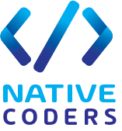

NativeCoders

TutorME - Tutoring Service Finder for University Students

Milestone 01 - Identify user groups

Kumarathunga S. A. D. S. - IT21118340

Rashen W.G.M - IT21291364

Kumanayake I. A. - IT21267772

Siriwardhana S.M.R.R. - IT21388934

User Experience Engineering SE3050

Department of Computer Science and Software Engineering, Faculty of Computing, Sri Lanka Institute of Information Technology (SLIIT)

# User Personas

## IT21118340

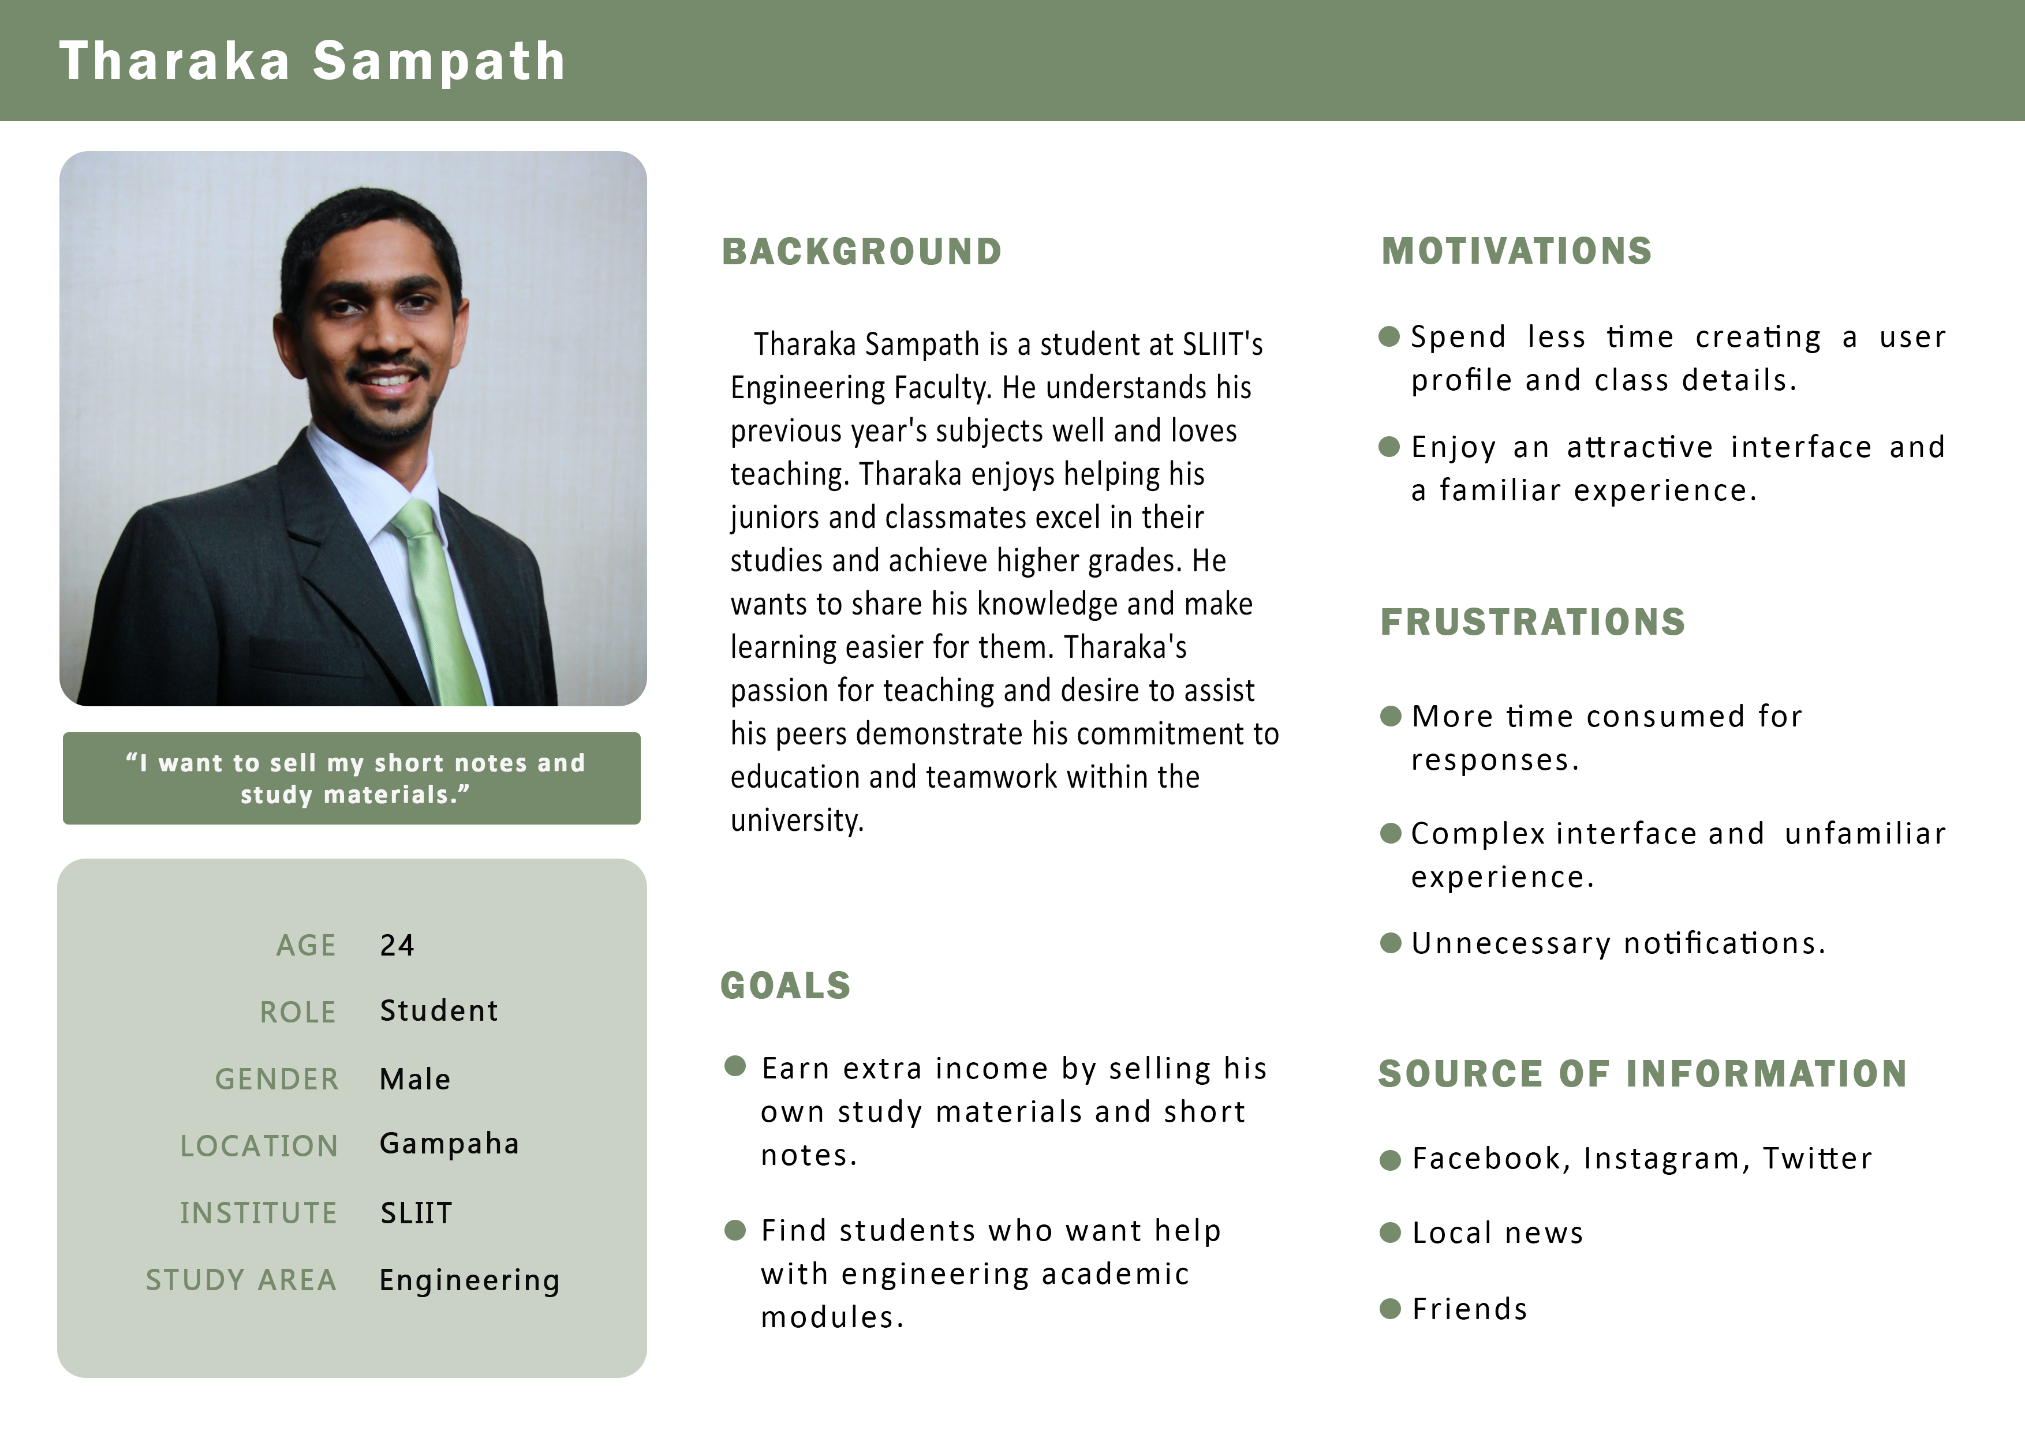

## IT21291364

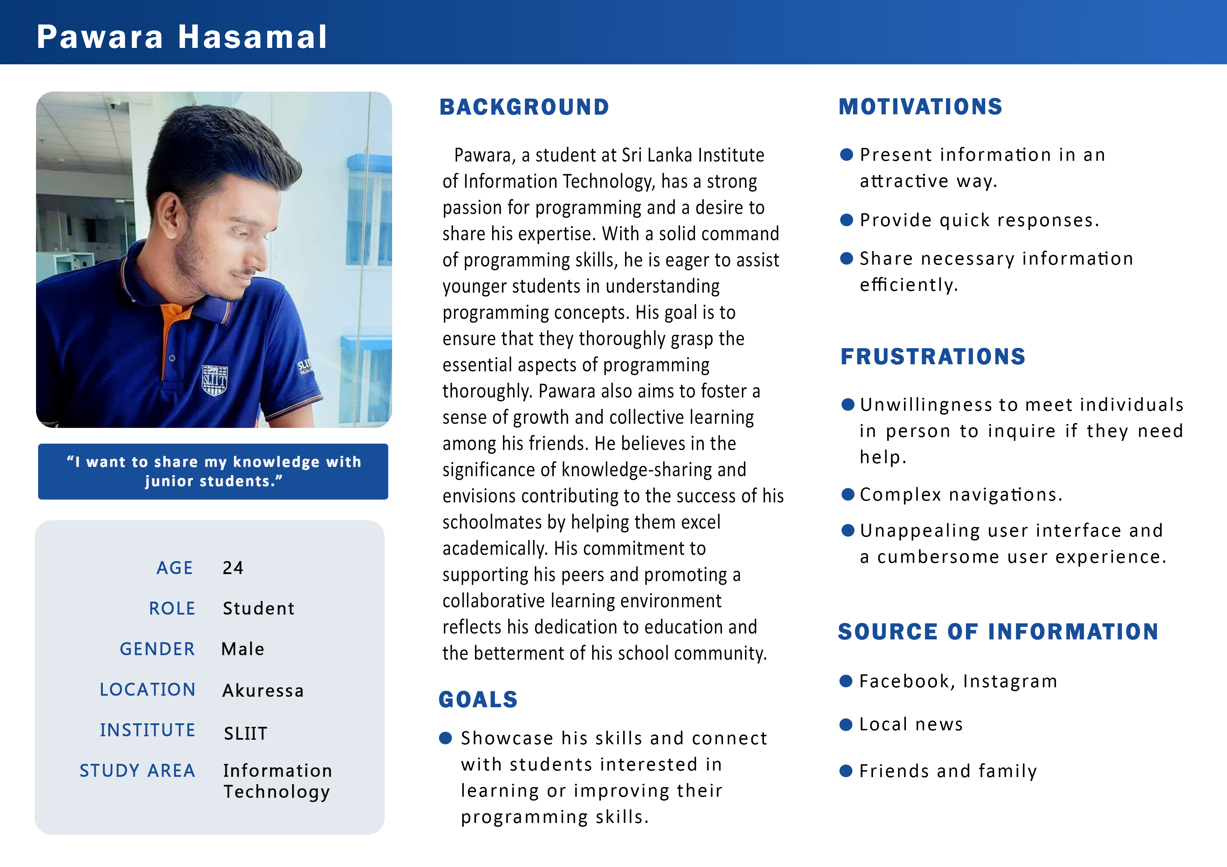

## IT21267772

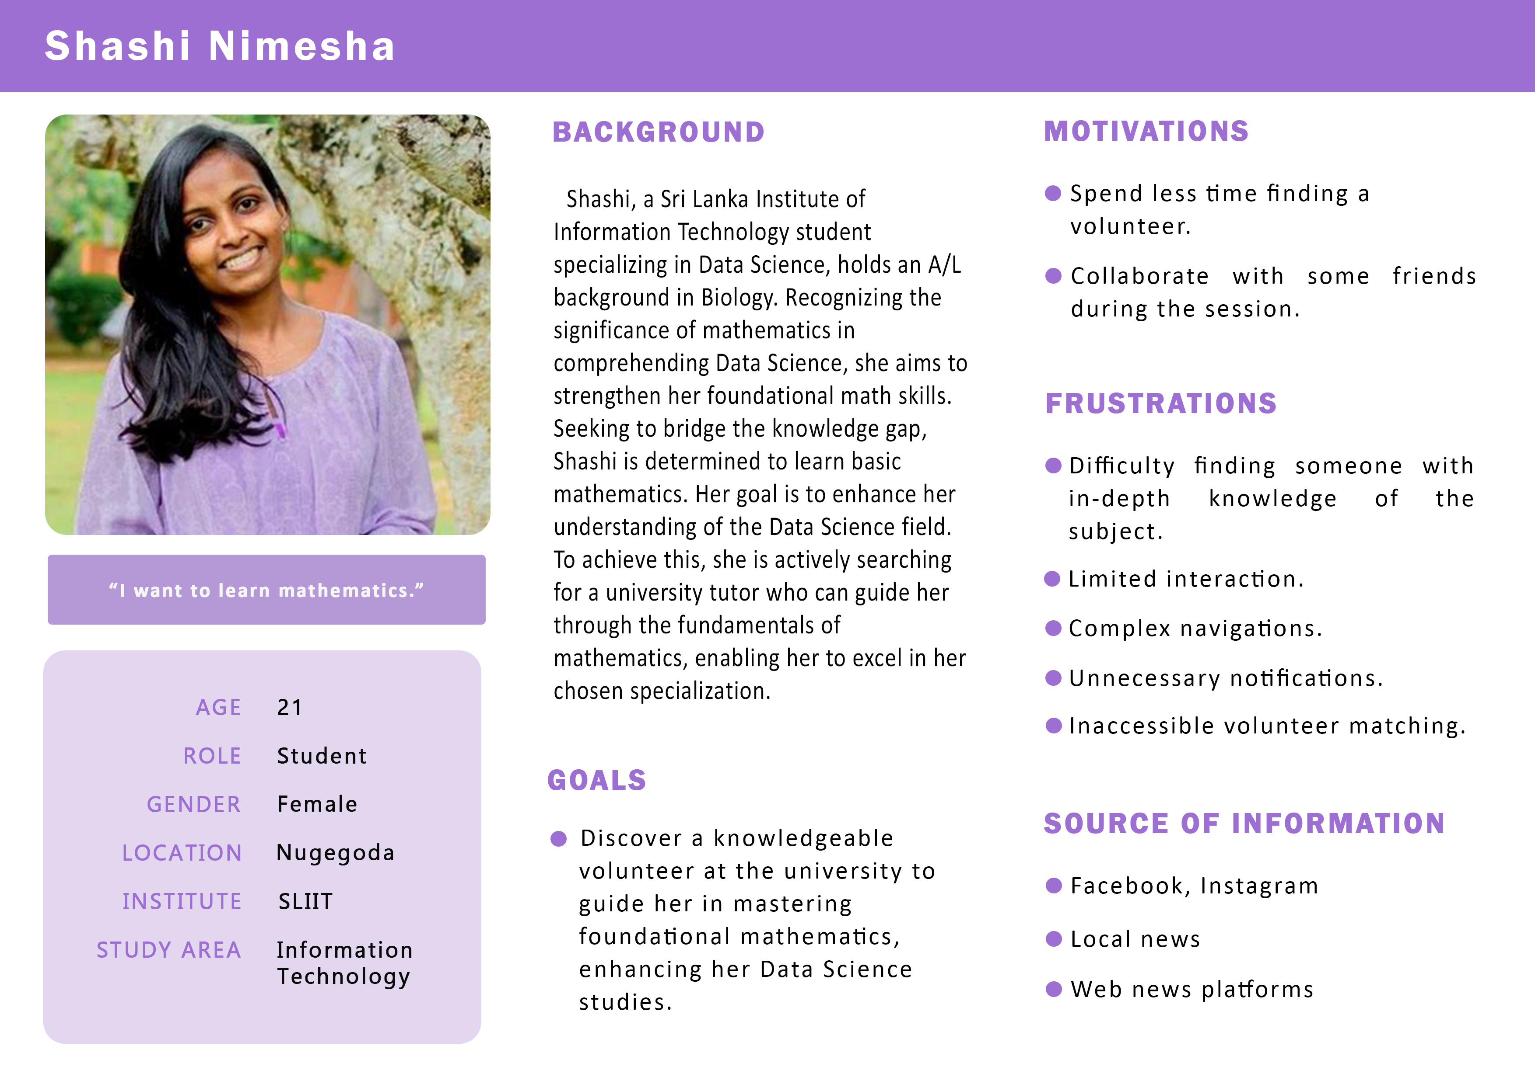

## IT21388934

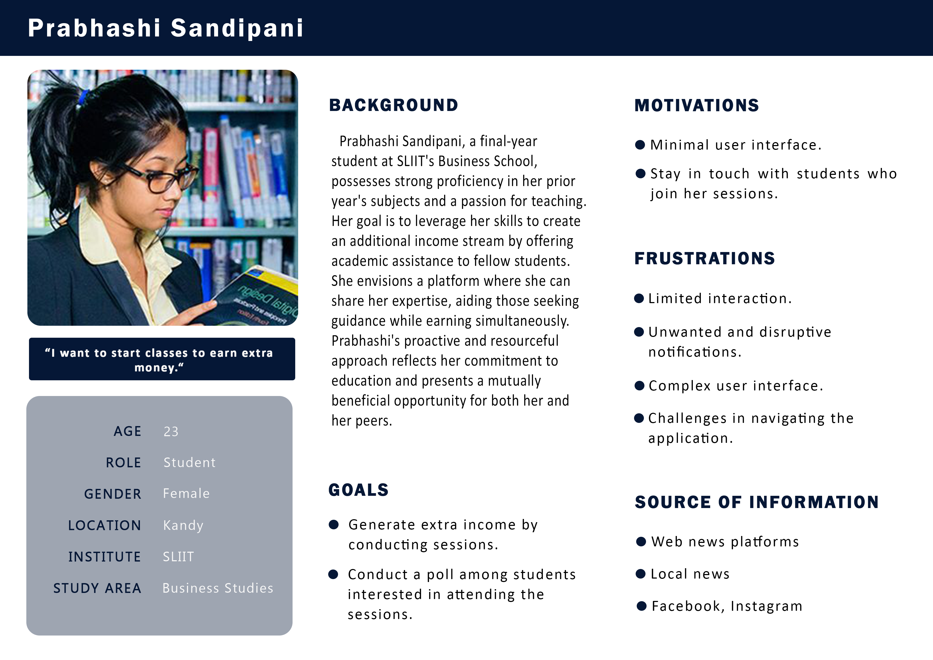

# Empathy Maps

## IT21118340

## IT21291364

## IT21267772

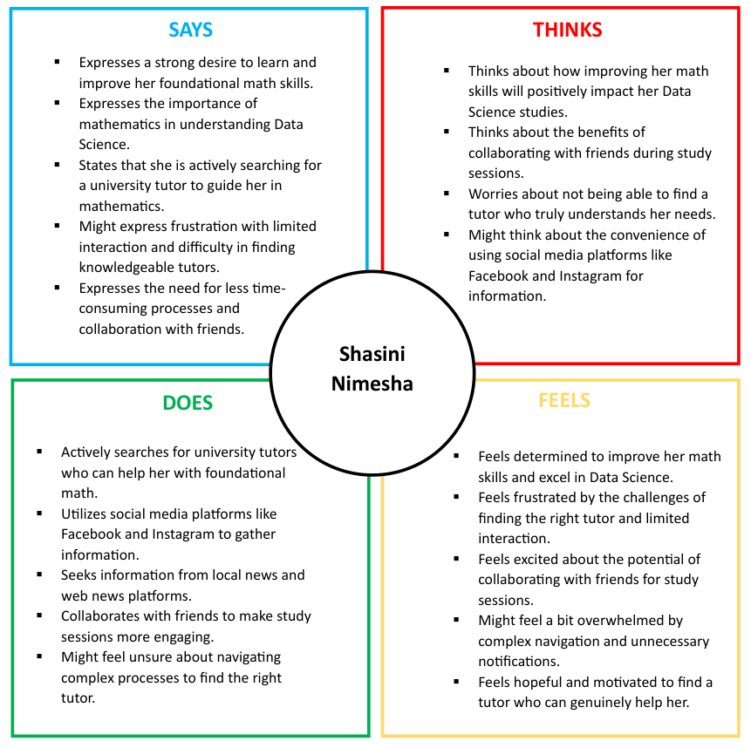

## IT21388934

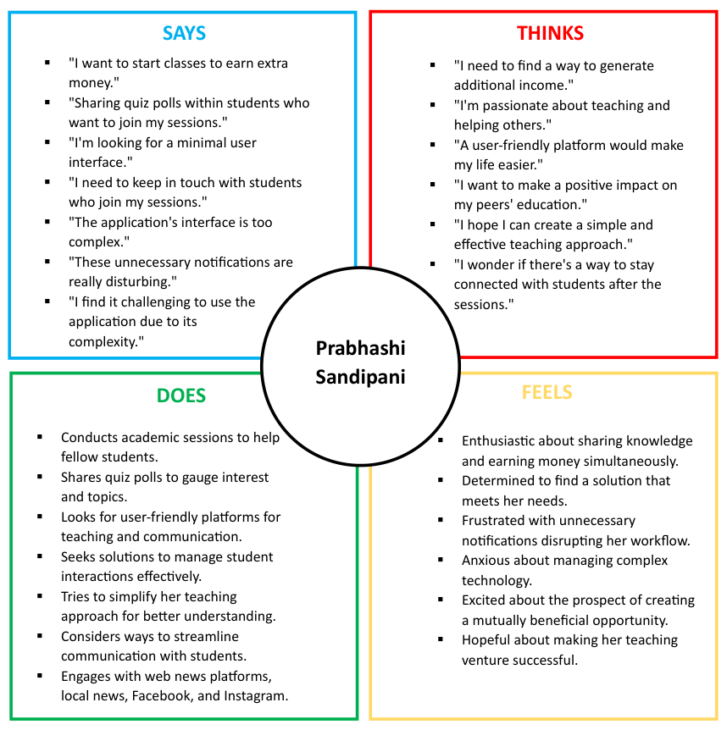

# User Stories

## IT21118340

**As a** student tutor,

**I want to** sell my short notes and study material

**So that** I can earn extra income

## IT21291364

**As a** university student,

**I want to** rate the tutor,

**So that** I can provide feedback about their abilities

## IT21267772

**As a** university student,

**I want to** easily request a session with a student tutor

**So that** I can schedule a session with them

## IT21388934

**As a** student tutor,

**I want to** to create and display information regarding classes I conduct

**So that** students seeking tutoring can make informed decisions

# User Flow Diagrams

## IT21118340: Student - Buy study materials

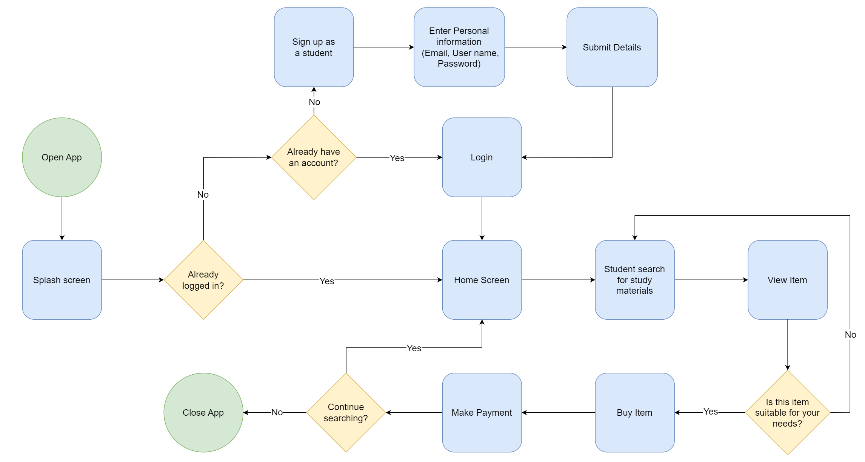

## IT21118340: Tutor - Publish study materials

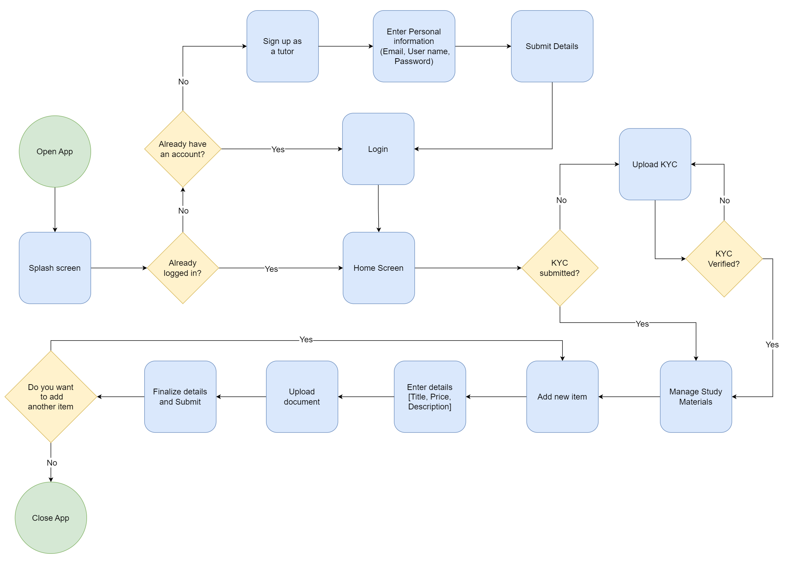

## IT21291364: Tutor - Manage profile

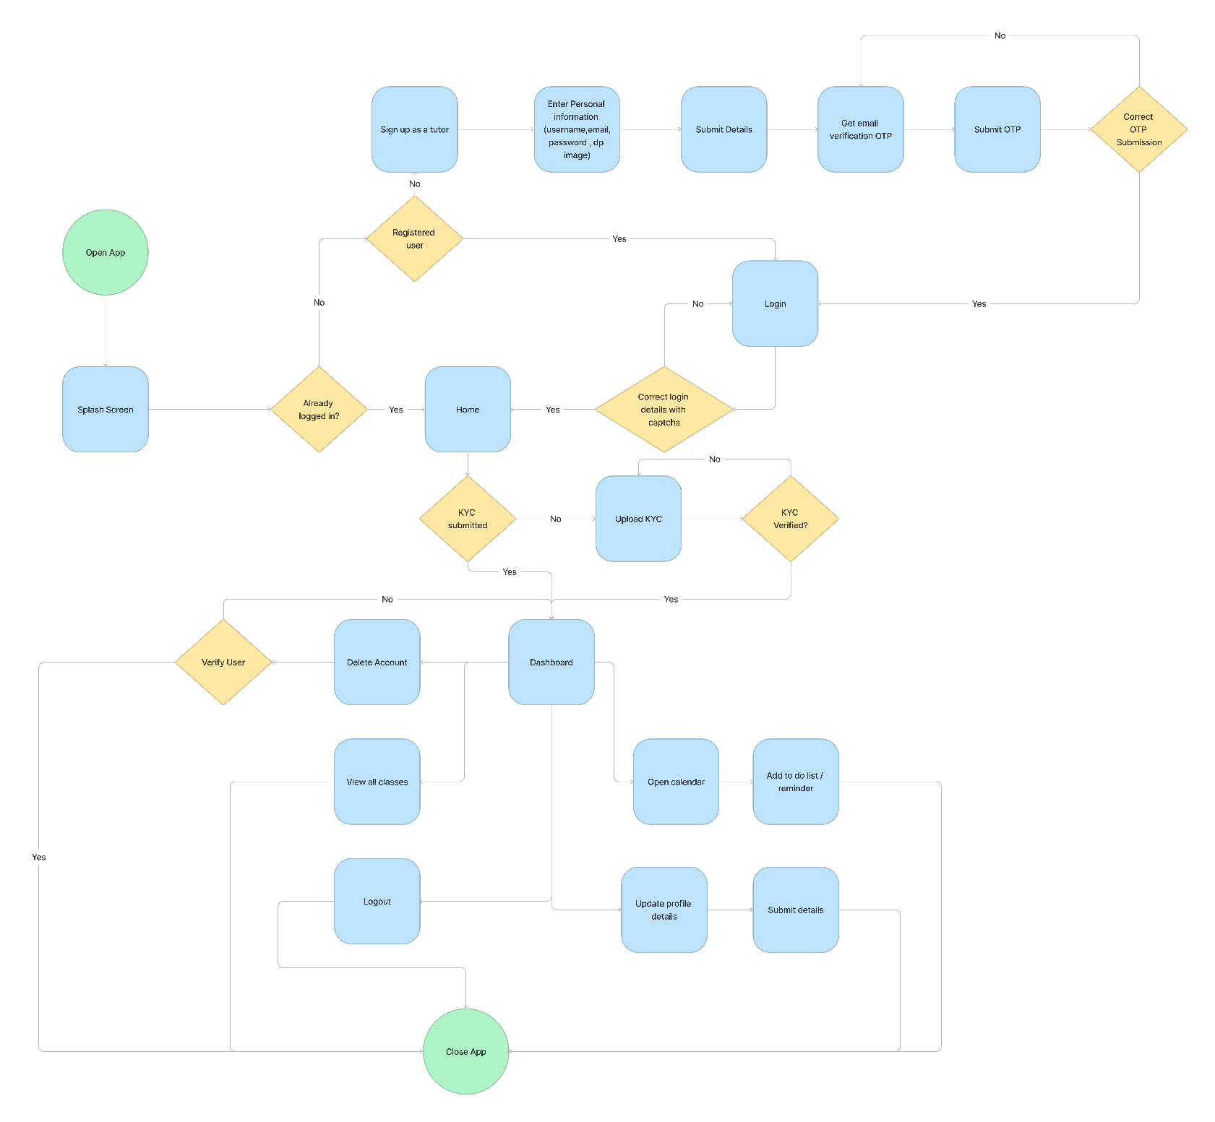

## IT21267772: Student - Book class



## IT21388934: Tutor - Publish Class



# Service Blueprint

### For Tutor

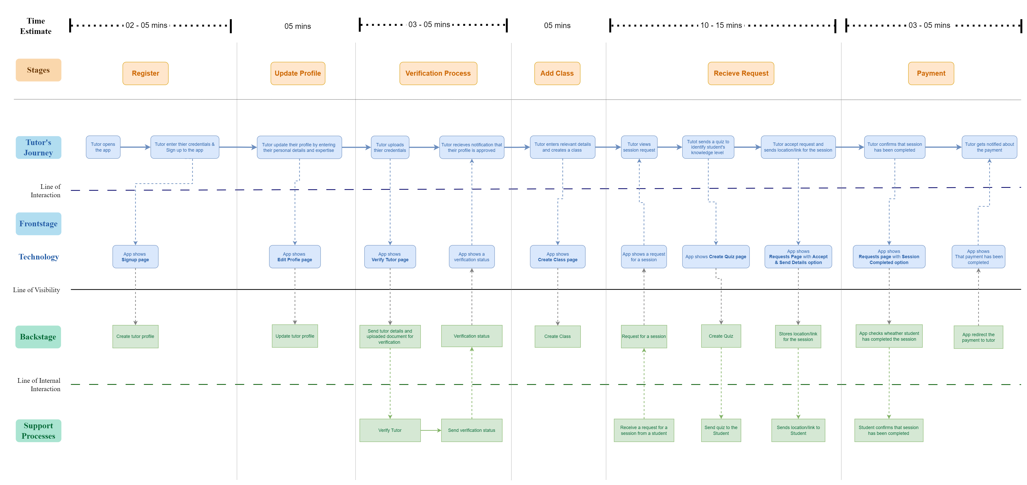

### For Student

